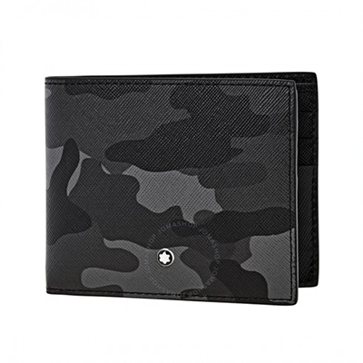

Montblanc Sartorial 6 cc Wallet- Camouflage Grey

PRODUCT DETAILS

**BRAND: Montblanc**

**SERIES: Sartorial**

**GENDER: Unisex**

**MODEL: 118673**

**COLOR: Grey**